Software Requirements Specification

for

Comorbidity and Genetic Factors and their Impacts on Patients with
COVID-19

Version 1.0.5 approved

Prepared by
Rohan Chatterjee Project Lead
Riese Atianzar Developer
Francisco Contreras Developer
Luis Gonzalez Developer
Emily Gonzalez Developer
Ting Fung Ha Developer
Juan Hernandez Developer
Carlos Hernandez Developer
Jimuel Cedrick Julaton Developer
Chen-Ching Lin Developer
Dr. Navid Amini Faculty Advisor

Sponsored by Vodafone

21 November 2022

Table of Contents
Table of Contents.................................................................................................................. pg 3
Revision History................................................................................................................... pg 5
1. Introduction................................................................................................................ pg 6
1.1. Purpose........................................................................................................... pg 6
1.2. Intended Audience and Reading Suggestions................................................ pg 6
1.3. Product Scope............................................................................................... pg 6
1.4. Definitions, Acronyms, and Abbreviations .................................................. pg 6
1.5. References...................................................................................................... pg 7
2. Overall Description.................................................................................................... pg 8
2.1. System Analysis…......................................................................................... pg 8
2.2. Product Perspective........................................................................................... pg 8
2.3. Product Functions........................................................................................... pg 9
2.4. User Classes and Characteristics.................................................................... pg 9
2.5. Operating Environment.................................................................................. pg 10
2.6. Design and Implementation Constraints........................................................ pg 10
2.7. User Documentation...................................................................................... pg 10
2.8. Assumptions and Dependencies.................................................................... pg 11
2.9. Apportioning of Requirements...................................................................... pg 11
3. External Interface Requirements............................................................................... pg 12
3.1. User Interfaces............................................................................................... pg 12
3.2. Hardware Interfaces....................................................................................... pg 13
3.3. Software Interfaces........................................................................................ pg 14
3.4. Communications Interfaces........................................................................... pg 14

4. Requirements Specification....................................................................................... pg 15
4.1. Functional Requirements............................................................................... pg 15
4.2. External Interface Requirements................................................................... pg 15
4.3. Logical Database Requirements.................................................................... pg 16
4.4. Design Constraints......................................................................................... pg 16
5. Other Nonfunctional Requirements........................................................................... pg 16
5.1. Performance Requirements............................................................................ pg 16
5.2. Safety Requirements......................................................................................... pg 17
5.3. Security Requirements................................................................................... pg 17
5.4. Software Quality Attributes........................................................................... pg 17
5.5. Business Rules............................................................................................... pg 17
6. Legal and Ethical Considerations.….......................................................................... pg 18
Appendix A: Glossary........................................................................................................ pg 18
Appendix C: To Be Determined List................................................................................. pg 19

Revision History
Name | Date | Reason For Changes | Version
Ting Fung Ha | November 21, 2022 | Document creation | 1.0.0
Ting Fung Ha | November 26, 2022 | First Draft Completed | 1.0.1
All members | November 28, 2022 | First Group Revision | 1.0.2
All members | December 1, 2022 | Second Revision | 1.0.3
Francisco Contreras | December 7, 2022 | Revision/additions to document | 1.0.4
Francisco Contreras | December 8, 2022 | Revision/Additions to document | 1.0.5

1. Introduction
1.1 Purpose
This document will provide a detailed explanation of the components within the application, the purpose for creating this application, as well as a general flow of the data from the beginning to the end. The document will also include the tools and technologies that was applied, how it was applied and some methods implemented for maintenance.
1.2 Intended Audience and Reading Suggestions
Analysts: It is recommended for analysts to go through Section 2 to 3 and 5 to 7. These sections will introduce some of the origin of the datasets, along with tools and technologies applied to this project.
Data Scientists: Data scientists should also read Section 2 to 7 of this document.
Medical Professionals: Medical professionals can refer to Section 2 and 5 for more relevant information.
For anyone with an interest in the project, it is recommended to read through the entire document to get a full understanding of this project.

1.3 Product Scope
Once released, the application will be able to accept an URL for the file and convert the datasets into visualizations based on their attributes. The application has a wide range of compatibility for PC, Android, iOS and other devices. All it needs is an internet connection.
1.4 Definitions, Acronyms, and Abbreviations
Refer to Appendix A.

1.5 References
1. Data-Driven Documents (D3) Overview
https://d3js.org/
2. Project Jupyter’s Origins and Governance
https://jupyter.org/about
3. Nodejs
https://nodejs.org/
4. GitHub
https://github.com/
5. Material UI
https://v4.mui.com/
6. Title: Software Requirements Document (Fall 2021)
Authors: Antonio Campos, Amy Guttman, Alec Kaczmarek, Vincent Li, Saiyang Liu, Ricardo Marroquin, Miguel Nonoal-Garcia, Alexandra Strong, Jonathan Sum, Edwin Zapata Minero
Date: November 27, 2022
7. Title: A Mobile Assistive Technology for Peripheral Visual Field Loss
Authors: Daniel Esparza, Canhong Huang, Jonathan Kan, Abran Lezama Pastor, Brenden Mccabe, Ashley Munoz, Uchenna Onuigbo, Duy Pham, Nicolas Sandoval, Jacob Schultz
Date: November 27, 2022

2. Overall Description
2.1 System Analysis
Millions of lives were changed ever since the COVID-19 pandemic in 2020. People from around the world were forced to live and act differently, because the virus can potentially infect any human being. In the time being, millions lost their lives, while countless more recovered but have to live with post-COVID-19-conditions.
The first part of the project allowed all the members in the group to learn, research and analyze the data obtained from trustful organizations. Then, the team created visualizations to see the identify the resemblances between some of the key attributes.
The application is created to describe the significance of the virus with visual illustrations. Users with access to the application should be able to customize their own view windows by adjusting some of the attributes provided from datasets posted from different trusted organizations.
Some of the major obstacles for this project are:
· Learning the different types of tools and how to implement it
· Finding a method to deal with the large quantity of data
These obstacles were crossed with instructional videos from YouTube, guidelines from the respective tools and demonstrations from other educational websites.

2.2 Product Perspective
This application shares some functionality from the COVID-19 trackers created by John Hopkins University. Both applications take in data from trusted sites and convert it into visualizations for the public to see. However, our application will focus more on the visualization aspect rather than just simply tracking it. The customization view window is based on the user’s preference and is completely independent from the tracker. Therefore, the visualizations will allow users to interact and generate customized views based on the selected dataset.

2.3 Product Functions
2.3.1.1 Home Screen
This is the page every user will see during their visit. The user will able to select datasets from trusted providers in the public and private sectors.
2.3.1.2 Navigation Bar
Act as a shortcut for users to access some of the useful pages immediately
2.3.1.3 Data Visualization Page
After a dataset was selected from the providers from the Home Screen, the dataset will turn into a visualization. The visualizations will appear underneath the first featured visualization for users to get a closer look.
2.3.1.4 Data Filter
Once a visualization is selected in the Data Visualization Page, the user will be able to see the dataset with some boundaries placed by the user.
2.3.2 Tableau Portal
A portal which contains visualizations created through the Tableau software. These visualizations will be remade for the Javascript application.

2.4 User Classes and Characteristics
The application does not have any user classes implemented. All users will see and interact with the same interface.

2.5 Operating Environment
The application will be running on modern browsers such as Google Chrome, Firefox, Explore, etc. In terms of operating systems on desktops any can run the application as long as it supports a modern browser along with it being up-to-date. It is recommended to have the browsers be on the latest version however, if the browser is in one of the few past versions, it will still run the application. In terms of mobile operating systems the application will run from iOS version 14 to the latest iOS version. For Android the application can run from version 10 to the latest. The Tableau portal will run on any browser provided that the user has an internet connection.

2.6 Design and Implementation Constraints
Developers will need to know the following tools before starting:
· JavaScript
· React
· Material UI
· D3.js
· Node.js
· GitHub
· Python 3.7+
· Dataset Providers

2.7 User Documentation
No additional documents provided at this time.

2.8 Assumptions and Dependencies
Any user who wishes to access the application is expected to have a device with an internet connection. The device is recommended to have an up-to-date modern browser and operating system. We plan to use the libraries React, D3, and Material UI to assist us in making an efficient application.

2.9 Apportioning of Requirements
Visualizations can delay the application due to large dataset size. The tools will have to utilize more computation power to convert these datasets into visualizations.
Customizations will slow down the performance of the application. The convenience allows the user to view the dataset based on their own preference. The drawback, however, will take longer to generate the view.

3. External Interface Requirements
3.1 User Interfaces
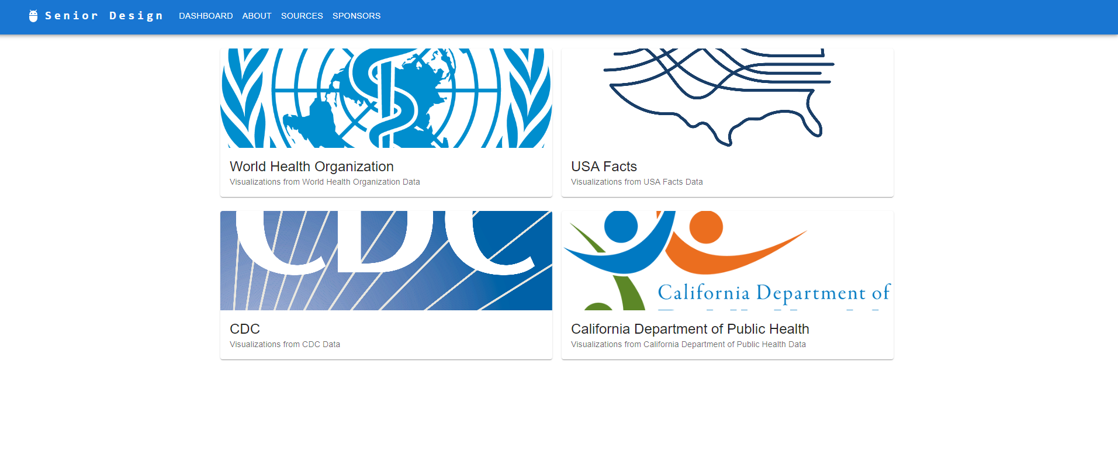
This is the landing page for the application. Any user who accesses the application will be greeted with this screen which contains datasets used which the user can go to. These dataset logos and subtext are in card form which a user can click on. The interfaces are simple in design to let the user focus.

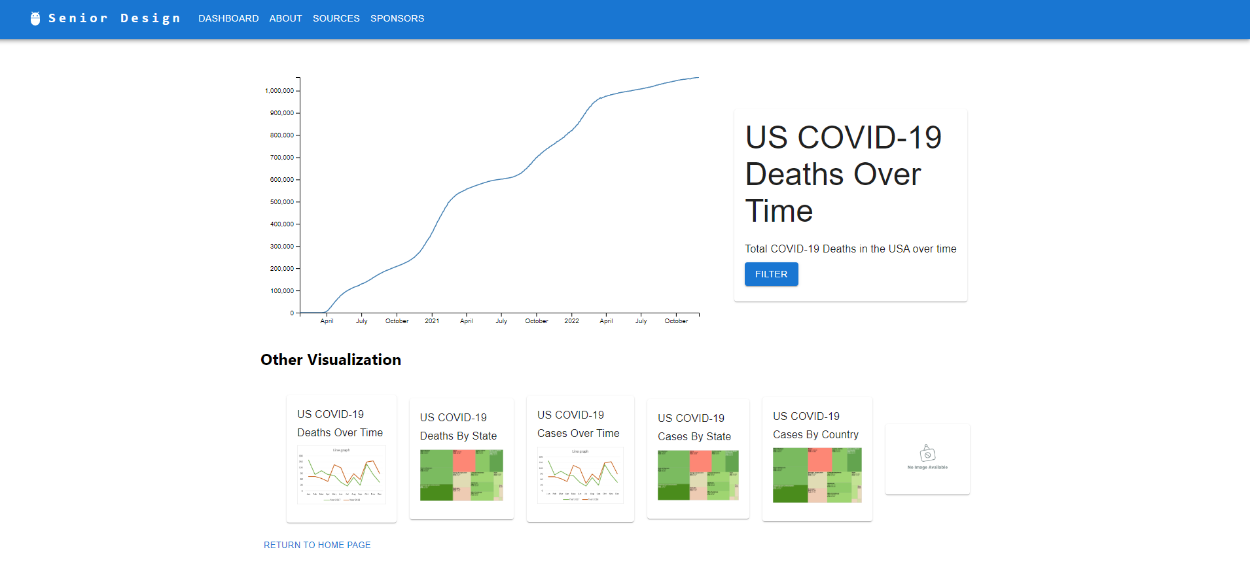
The user will be greeted with this interface when a user clicks on one of the dataset cards. The bottom shows previews of all the visualizations made from the dataset. The top will display a full view of the selected visualization. The blue filter button on the right is a future planned implementation for the user to filter certain visualizations they wish to see.
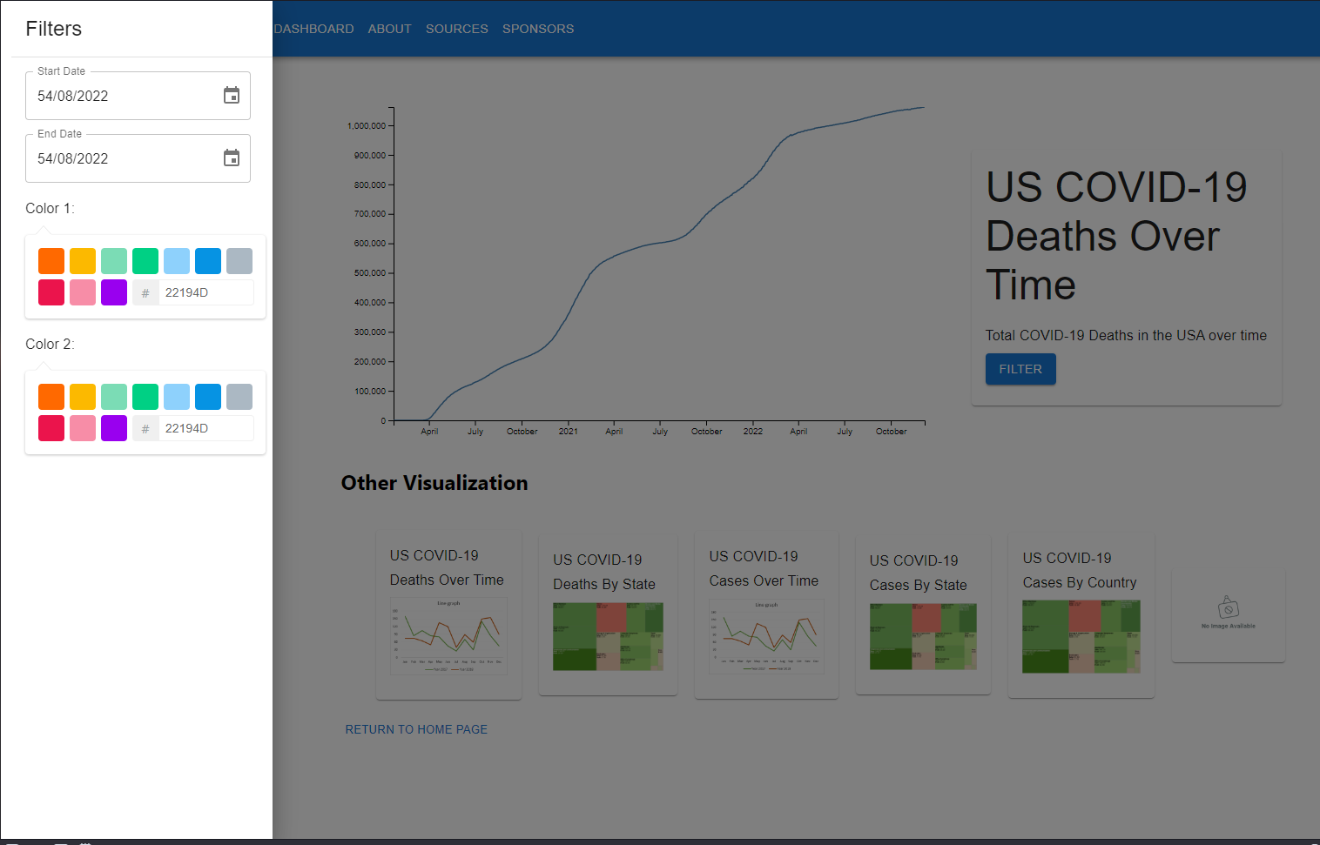
This sidebar interface will be the interface that will appear once the user clicks the filter button. This interface will allow the user to filter to see the visualizations they desire. The sidebar will disappear once the user clicks on somewhere on the application that is not the sidebar. It is currently not fully implemented, but will be fleshed out.

3.2 Hardware Interfaces
There are no hardware interfaces available at this time.

3.3 Software Interfaces
The project utilized various software programs to achieve our goals. In part one the project, the team used Tableau Public and Tableau Desktop for data analysis and created visualizations. The results were published on Tableau Portal, which is a website.
A number of JavaScript libraries and APIs were selected during the development phase. These tools include:
- D3.js
- JavaScript Fetch API
- Material UI
- Node.js
- React

3.4 Communications Interfaces
The application can be accessed with a valid URL. This is achieved with a browser, the JavaScript Fetch API, D3 API, HTTP connection and a stable internet connection. The encryption will be handled by the browser, while data transfer rate will depend on the internet connection.
JavaScript fetch API
D3 API
HTTP
Stable internet connection required

4. Requirements Specification
4.1 Functional Requirements
The application shall take a dataset link from a reputable source
The application shall read through the dataset
The application shall create visualizations from the dataset
The application shall make the visualizations interactive
The application should implement a filter system for the visualizations
The application should display filtered visualizations based on user’s preference
The application shall display previews of visualizations from desired dataset
The application shall display a full-sized visualization from the user’s desired visualization
The application shall change interfaces depending on the users input
The application shall keep track of most up-to-date entries from used datasets

4.2 External Interface Requirements
There are no applicable requirements for this software at this time

4.3 Logical Database Requirements
The application will not use a database to generate visualizations, but APIs were used to fetch for additional resources.
No databases were used at this time.

4.4 Design Constraints
All of the design constraints came from part two of the project, an application to create visualizations based on a dataset. In order to get useful data and create impactful visualizations, the team will have to think of a method to display visualizations with a large file size quickly. Another constraint was to display the same contents with an optimized window for different devices. This challenged our team to make the application responsive and adaptive to different screen sizes.

5. Other Nonfunctional Requirements
5.1 Performance Requirements
The performance of the application will depend on device hardwares and internet characteristics. Visualizations should load within a few seconds if users have a stable internet speed greater or equal to 5 Mbps.
The hardware specification for this application will be less restrictive. Any devices that are capable of streaming the internet will suffice.

5.2 Safety Requirements
No safety requirement is specified.

5.3 Security Requirements
No security requirements implemented at this time.

5.4 Software Quality Attributes
The software will be compatible with different kinds of devices like mobile devices, personal computers, tablets, etc. The datasets will be monitored regularly to ensure its accuracy and trustworthiness.

5.5 Business Rules
No business rules applied at this time.

6. Legal and Ethical Considerations
There are some legal and ethical considerations, mainly from the datasets and its usages. Each member from the team is required to keep the data safe and accurate without any manipulations. At the same time, every member cannot defame the dataset providers for any reason.
Additional considerations and restrictions will apply to the team when we enter the third portion of the project, where the medical and physiological data provided by our sponsor will remain confidential.

Appendix A: Glossary
API: Application Programming Interface
GUI: Graphical User Interface
iOS: An operating system installed on all Apple mobile devices
JS: JavaScript
React: A JavaScript library specifically designed for user interface
Material UI: A language based on Material Design, created by Google.
D3.js: A JavaScript library for manipulating HTML data
Node.js: A cross-platform JavaScript runtime environment

Appendix C: To Be Determined List
Some of the functions that may be implemented in the future includes:
- Error Checking and Validations for each dataset
- Error messages and functions for overflow handling
- Provide more attribute customizations for a dataset ( e,g, COVID-19 variants and etc.)
Error Checking and Validation
Overflow handling (size of visualizations get too big)
More customization windows based on their attributes (Create visuals if the dataset contains statistics for COVID-19 variants etc.)

